​

## Indian Institute of Technology Kanpur

​

​

## AE451A

​

​

## Experiments in Aerospace Engineering - III

​

​

# Experiment No. 5

​

​

## Laminar and turbulent boundary layers characteristics on a flat plate

​

### *Submitted By:*

Ankit Lakhiwal (180102)

[ankitl@iitk.ac.in](To:ankitl@iitk.ac.in)

Aerospace Engineering Department, IIT Kanpur

September 20, 2021

## Objective

To understand the features of laminar and turbulent boundary layers and characterize it based on its velocity profile, displacement thickness,momentum thickness, using a pitot tube and a differential manometer.

1. Introduction and theory

* **Boundary Layer**

A thin layer close to the solid body where the fluid velocity increases from zero at the wall (due to no-slip condition for viscous fluids) to its maximum value at the free stream (U∞) is called the boundary layer.

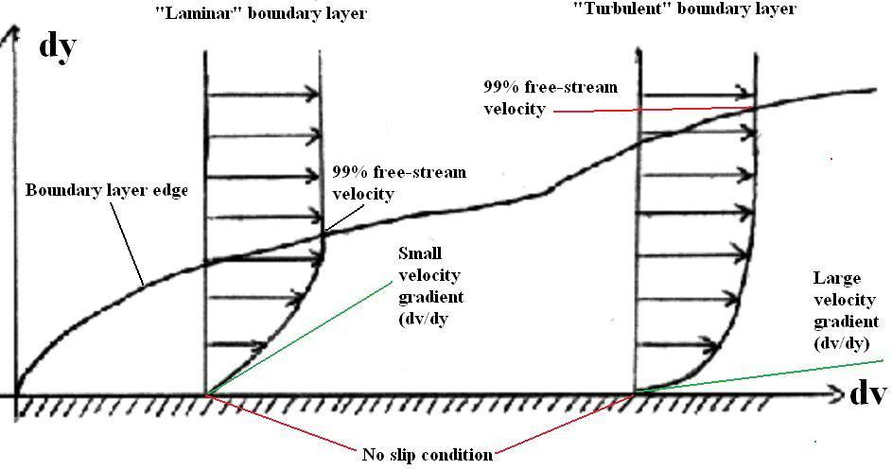

**Boundary layer thickness (δ):**

The distance from the wall where the mean velocity reaches 99% of free stream velocity.

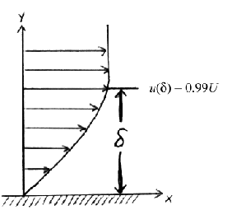

$δ ={ y |}_{@ u =0.99∗U∞}$**………(1)**

* **Displacement Thickness**

The displacement thickness is defined as the distance by which the wall would have to be displaced outward in a hypothetical friction-less flow so as to maintain the same mass flux as in the actual flow.

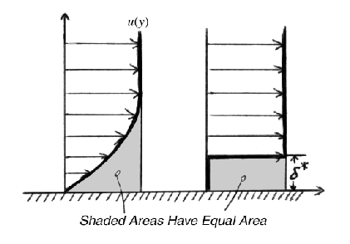

$δ^{∗}=\int_{0}^{∞}{(1 − \frac{u}{U∞}) dy}$……..(2)

* **Momentum Thickness**

Distance by which the streamlines have to be shifted in a potential flow so that it produces the same momentum loss produced by the presence of a boundary layer.

$θ=\int_{0}^{∞}{(1 − \frac{u}{U∞})\frac{u}{U∞} dy}$…….(3)

* **Shape Factor**

The ratio of displacement to momentum thickness,

$H = \frac{δ^{∗}}{θ}$………(4)

a parameter, which quantifies the relative importance of the mass and momentum diffusion.

All these parameters are common for the both laminar and turbulent boundary layer, but their values are different depending on the wall-normal velocity profile

* **Skin Friction Coefficient**

1. Laminar flow
   * 1. The skin friction coefficient Cf can be calculated based on the formula

* + 1. x – The distance between the leading edge and the measurement location.

1. Turbulent flow
   * 1. Fit the linear curve between $\frac{\overline{u}}{U_{∞}}$ and $\ln{(\frac{yU_{∞}}{ϑ})}$
     2. The slope of the curve gives the value of C in the equation given below. From C, we can find Cf

Where,

$\overline{u}$– measured velocity at a point,

U∞ - Free-stream velocity,

y- The location at which the velocity ($\overline{u}$) measured.

$$\frac{\overline{u}}{U_{∞}}= C∗\ln{(\frac{yU_{∞}}{ϑ})}+ D$$

$$C = \frac{1}{K}\sqrt{\frac{C_{f}}{2}} ............(5.2)$$

$$D = \sqrt{\frac{C_{f}}{2}} \left\{\frac{1}{K}\ln\left\{\sqrt{\frac{C_{f}}{2}}\right\} + B\right\}$$

With K = 0.41 and B = 5.0

* **Theoretical Formulas**

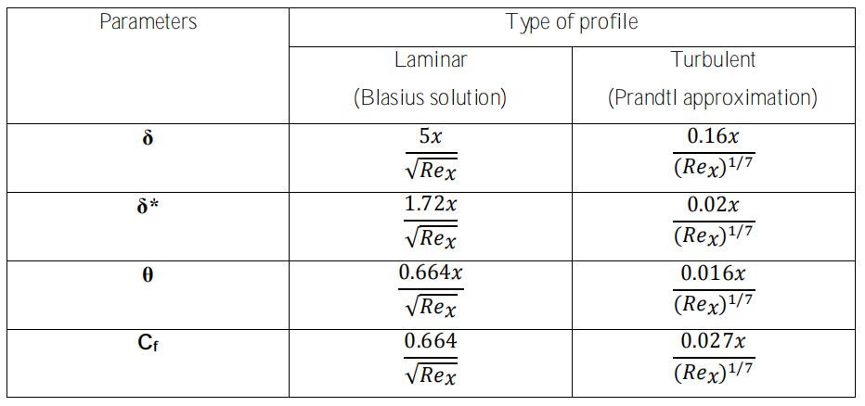

1. Equipment's
   1. Wind Tunnel

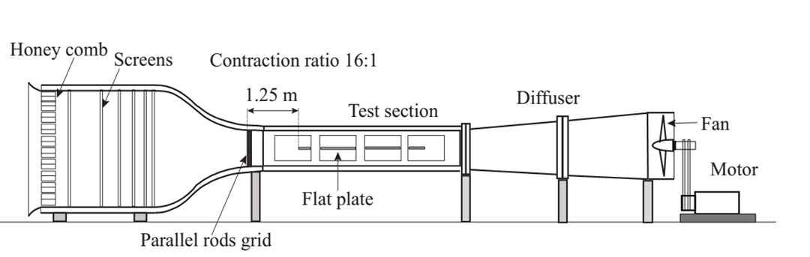

* 1. Flat plate

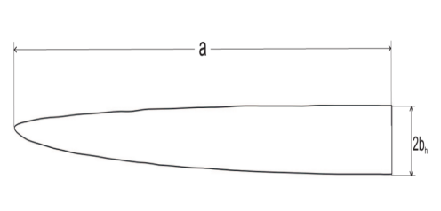

* 1. Pitot tube

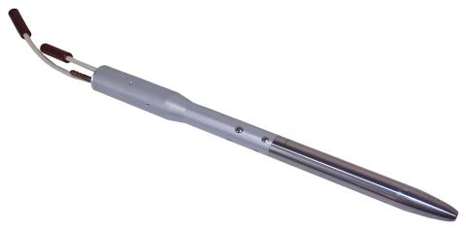

* 1. Digital differential manometer

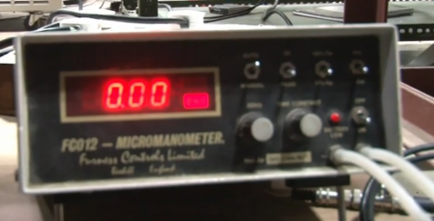

* 1. NI data acquisition system.

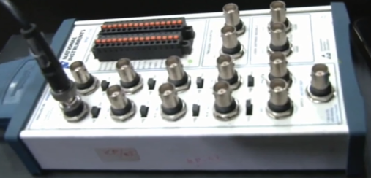

* 1. Computer



1. Procedure
   1. Take a picture of the experimental setup. Note the geometry of the flat plate leading edge, and the smoothness of the surface.
   2. Take a picture of the traversing mechanism and the miniature Pitot probe.
   3. Make a block diagram of the experimental setup, including the DAQ system.
   4. Mount the miniature Pitot tube in the horizontal traversing mechanism.
   5. Connect the Pitot tube lead to a digital micro-manometer.
   6. At one free stream wind speed at a stream-wise station, x, measure velocity profiles in the laminar and the turbulent boundary layer. The origin of x coordinate is at the flat plate leading edge, and it is increasing in the stream-wise direction. Note that you can have turbulent boundary layer at the same stream-wise station by introducing roughness or a tripping element at the leading edge of the plate.
   7. Plot velocity profiles and obtain wall shear stress and boundary layer thicknesses. Note the differences between laminar and turbulent boundary layer velocity profiles and understand why they are different.
2. Measurements and specifications
   1. **Wind Tunnel specifications:**
      1. Open non-return suction type
      2. Contraction ratio : 16:1
      3. Operational speed : 3 to 18 m/s
      4. No of screens : 6, square mesh 1mm.
      5. Honeycomb : square 1ft long.
      6. Test section : 610 x 610mm square cross section, 10ft long.
      7. Motor Specs : A.C induction motor, 15hp, 50 Hz, 1445 max rpm.
      8. Diffuser : Square section of 10ft long.
   2. **Flat plate Specifications:**
      1. Leading edge - Asymmetrical Modified super ellipse
      2. Material - Acrylic-glass
      3. Geometry - 2 m long, 0.61 m width, 12 mm thick
      4. Semi major axis, a =120mm; ARu= 30, ARl = 15.
   3. **Pitot tube:**
      1. Used for measuring the total pressure of the flow.
      2. Static pressure is measured using a port drilled in the tunnel wall.
   4. **Digital differential manometer:**
      1. Range – 20 mm of H2O (= 200 Pascal which is = 5V).
      2. Furness FC012 digital manometer.
   5. **Data Acquisition System:**
      1. PXI – 1073 chassis.
      2. NI-PXI 6251, 16 bit data acquisition card.
      3. BNC 2120 signal I/O board
3. Experimental data analysis
   1. **PIV data**
      1. **Graph between y vs velocity**

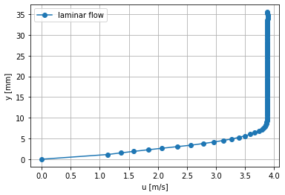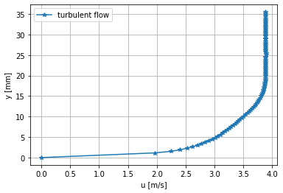

* + 1. **Graph (1-u/Uinf) and (u/Uinf)*(1-u/Uinf) vs y**
       1. **Laminar flow**

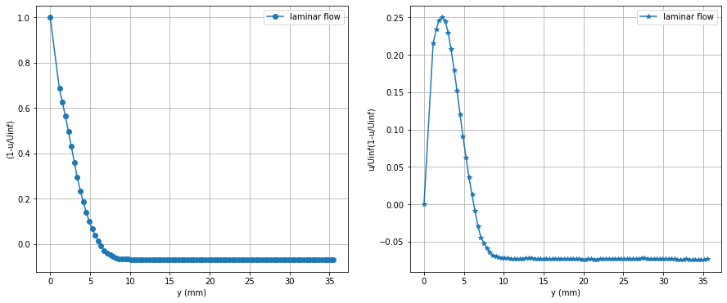

* + - 1. **Turbulent flow**

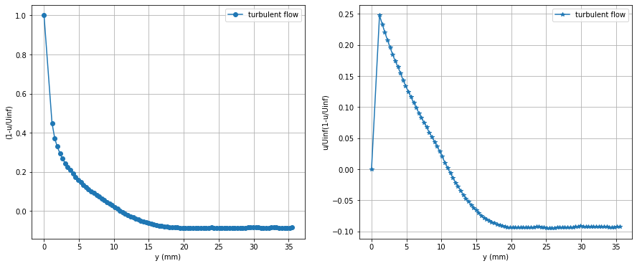

|  |  |  |  |
| --- | --- | --- | --- |
| **Parameters** | **Dimension** | **Experimental** | |
| **Laminar** | **Turbulent** |
| $U_{∞}$ (Free stream velocity) | m/s | 3.6343 | 3.575 |
| δ (Boundary layer thickness) | mm | 6.0755 | 10.5347 |
| δ* (Displacement thickness) | mm | 2.1128 | 1.8595 |
| θ(Momentum thickness) | mm | 1.021 | 1.3429 |
| H (shape factor) | - | 2.068 | 1.3846 |
| Cf | - | 0.001571 | 0.00261 |

* 1. **Pitote Tube data**
     1. **Graph between y vs velocity**

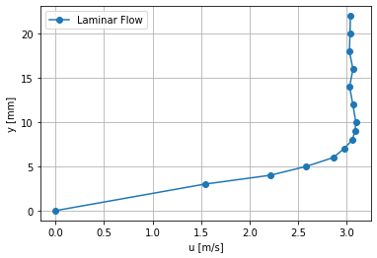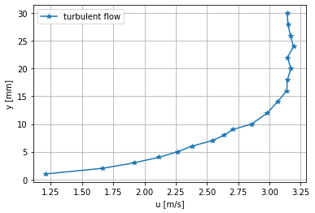

* + 1. **Graph (1-u/Uinf) and (u/Uinf)*(1-u/Uinf) vs y**
       1. **Laminar flow**

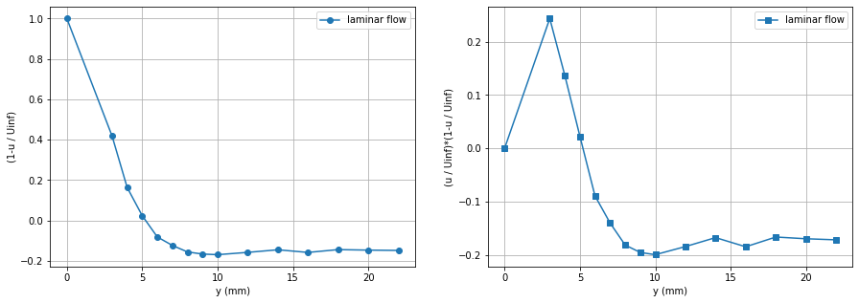

* + - 1. **Turbulent flow**

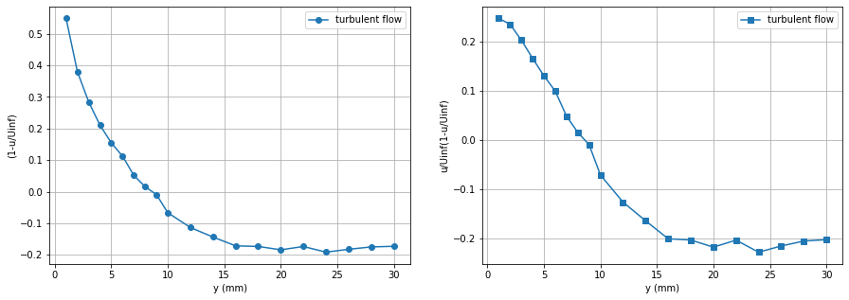

|  |  |  |  |
| --- | --- | --- | --- |
| **Parameters** | **Dimension** | **Experimental** | |
| **Laminar** | **Turbulent** |
| $U_{∞}$ (Free stream velocity) | m/s | 2.644 | 2.679 |
| δ (Boundary layer thickness) | mm | 5.125 | 8.2242 |
| δ* (Displacement thickness) | mm | 1.4396 | 1.758 |
| θ(Momentum thickness) | mm | 0.889 | 1.1475 |
| H (shape factor) | - | 1.62 | 1.532 |
| Cf | - | 0.001367 | 0.00344 |

* 1. **Blasius data**
     1. **Comparison BTW PIV and blasius data**

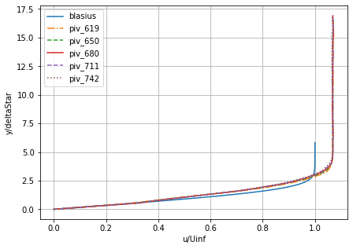

* + 1. **Comparison BTW Pitote and blasius data**

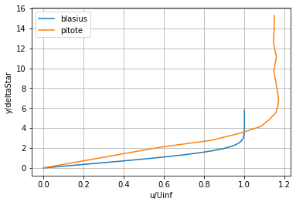

1. Theoretical calculation

Using Theoretical formula table

* 1. **PIV data**

|  |  |  |  |
| --- | --- | --- | --- |
| **Parameters** | **Dimension** | **Theoretical** | |
| **Laminar** | **Turbulent** |
| $U_{∞}$ (Free stream velocity) | m/s | 3.634 | 3.575 |
| δ (Boundary layer thickness) | mm | 8.135 | 18.794 |
| δ* (Displacement thickness) | mm | 2.79 | 2.35 |
| θ(Momentum thickness) | mm | 1.0803 | 1.88 |
| H (shape factor) | - | 2.6 | 1.25 |
| Cf | - | 0.00166 | 0.00488 |

* 1. **Pitote data**

|  |  |  |  |
| --- | --- | --- | --- |
| **Parameters** | **Dimension** | **Theoretical** | |
| **Laminar** | **Turbulent** |
| $U_{∞}$ (Free stream velocity) | m/s | 2.644 | 2.679 |
| δ (Boundary layer thickness) | mm | 9.54 | 19.58 |
| δ* (Displacement thickness) | mm | 3.2805 | 2.45 |
| θ(Momentum thickness) | mm | 1.26645 | 1.9584 |
| H (shape factor) | - | 2.59 | 1.25 |
| Cf | - | 0.00195 | 0.00508 |

1. Results ans discussion
   1. **PIV data**

|  |  |  |  |  |  |
| --- | --- | --- | --- | --- | --- |
| **Parameters** | **Dimensions** | **Laminar** | | **Turbulent** | |
| Experimental | Theoretical | Experimental | Theoretical |
| $U_{∞}$ (Free stream velocity) | m/s | 3.6343 | 3.634 | 3.575 | 3.575 |
| δ (Boundary layer thickness) | mm | 6.0755 | 8.135 | 10.5347 | 18.794 |
| δ* (Displacement thickness) | mm | 2.1128 | 2.79 | 1.8595 | 2.35 |
| θ(Momentum thickness) | mm | 1.021 | 1.0803 | 1.3429 | 1.88 |
| H (shape factor) | - | 2.068 | 2.6 | 1.3846 | 1.25 |
| Cf | - | 0.001571 | 0.00166 | 0.00261 | 0.00488 |

* 1. **Pitote data**

|  |  |  |  |  |  |
| --- | --- | --- | --- | --- | --- |
| **Parameters** | **Dimensions** | **Laminar** | | **Turbulent** | |
| Experimental | Theoretical | Experimental | Theoretical |
| $U_{∞}$ (Free stream velocity) | m/s | 2.644 | 2.644 | 2.679 | 2.679 |
| δ (Boundary layer thickness) | mm | 5.125 | 9.54 | 8.2242 | 19.58 |
| δ* (Displacement thickness) | mm | 1.4396 | 3.2805 | 1.758 | 2.45 |
| θ(Momentum thickness) | mm | 0.889 | 1.26645 | 1.1475 | 1.9584 |
| H (shape factor) | - | 1.62 | 2.59 | 1.532 | 1.25 |
| Cf | - | 0.001367 | 0.00195 | 0.00344 | 0.00508 |

1. Questions
2. What do you understand by the probe displacement effect?

**Ans.**  The change in Pitote probe location disturb the flow near the flat plate and also there are some transient effects due to the motion of the tube.

1. How can you obtain local shear stress from the velocity profile data?

**Ans.** From the velocity profile data, we can calculate the local velocity gradient, which gives

$$τ_{x} = μ\left(\frac{∂u}{∂y}\right)x$$

1. What are displacement thickness and momentum thickness? How are they related to one another in the case of laminar and turbulent boundary layers?

**Ans**.

* **The displacement thickness,** δ* is defined as the distance by which the wall would have to be displaced outward in a hypothetical friction-less flow so as to maintain the same mass flux as in the actual flow.
* **The momentum thickness,** θ is defined as the distance by which the streamlines have to be shifted in a potential flow so that it produces the same momentum loss produced by the presence of a boundary layer.
* Shape factor H, describe the relation between δ* and θ

$$\frac{δ^{∗}}{θ}= H$$

1. Maximum resolution of the DAQ system?

**Ans. $\frac{5}{2^{16}} V$**

1. Why does a laminar boundary layer become turbulent?

**Ans.** A laminar boundary layer could be turbulent due change in Reynolds number(Re).

Reynolds number for laminar to turbulent boundary layer can vary for different shape and surface roughness of the specimen.

1. What do you understand by the transition and intermittency in a flat plate boundary layer?

**Ans.** The complex process of transition from laminar to turbulent flow involves the instability in the flow field. The small disturbances imposed on the boundary layer flow will either grow (i.e. instability) or decay (stability) depending on the location where the disturbance is introduced. If the disturbance occurs at a location where ${Re}_{x}$ < ${Re}_{xCR}$, then the boundary layer will return to laminar flow at that location. Disturbances imposed on locations ${Re}_{x}$ < ${Re}_{xCR}$ will grow and the boundary layer flow becomes turbulent from this location.

1. What is the critical Reynolds number for transition over a flat plate?

**Ans.** On a flat plate with a sharp leading edge in a typical free stream air flow, the transition occurs between the Reynolds number ranges of $2 x {10}^{5} to 3 x {10}^{6}$ So the transitional Reynolds number is normally taken as ${Re}_{xCR} = 5 x {10}^{5}$